

**Weekly Lab Student Report**

Week 4 Lab

Lab Title: Threats—Mitigation and Deterrent Techniques

Student Name: Roman Kovtun

Date: 11/21/2018

**Lab Diagram**



In this Lab, you will learn how to secure a network by doing the following tasks.

* How to disable unnecessary services to minimize the attack surface of a computer
* How to protect certain programs from being accessed by regular users using group policy
* How to rename nonessential built-in user accounts to prevent those accounts from being used by unauthorized users.

Paste your screenshots under the appropriate topic below.

1. Take a screenshot of the Exercise 1 Task 1 (policy to turn off nonessential services) Step 19. (10 points)

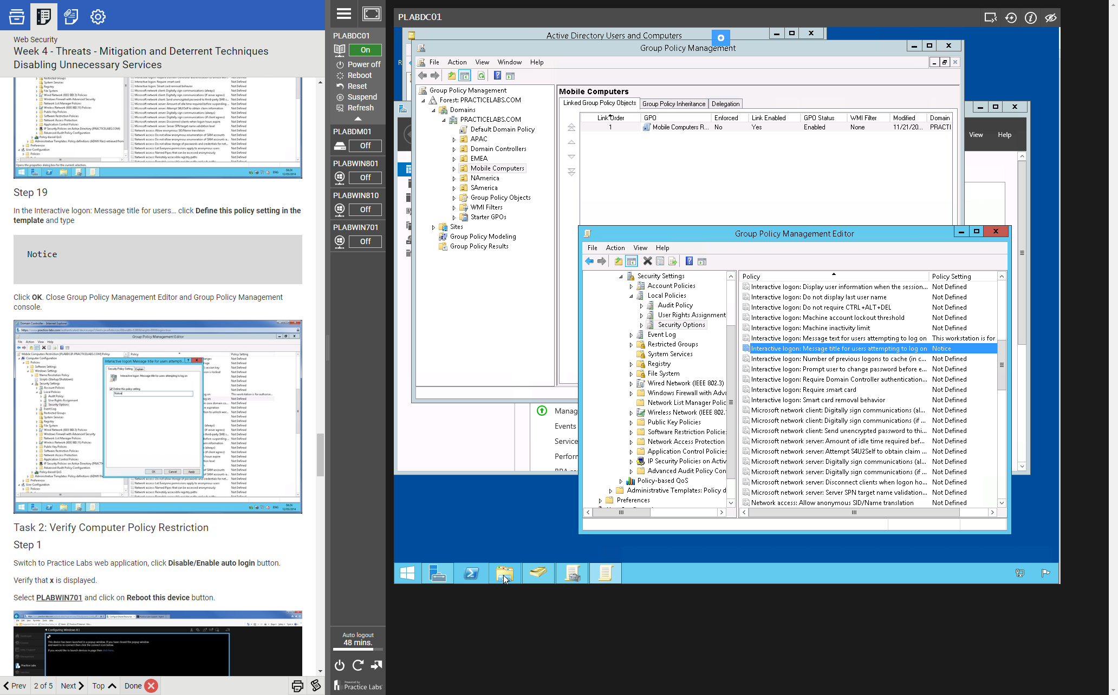

1. Take a screenshot of Exercise 1 Task 2 (verify computer policy restriction)   
   Step 10. (10 points)

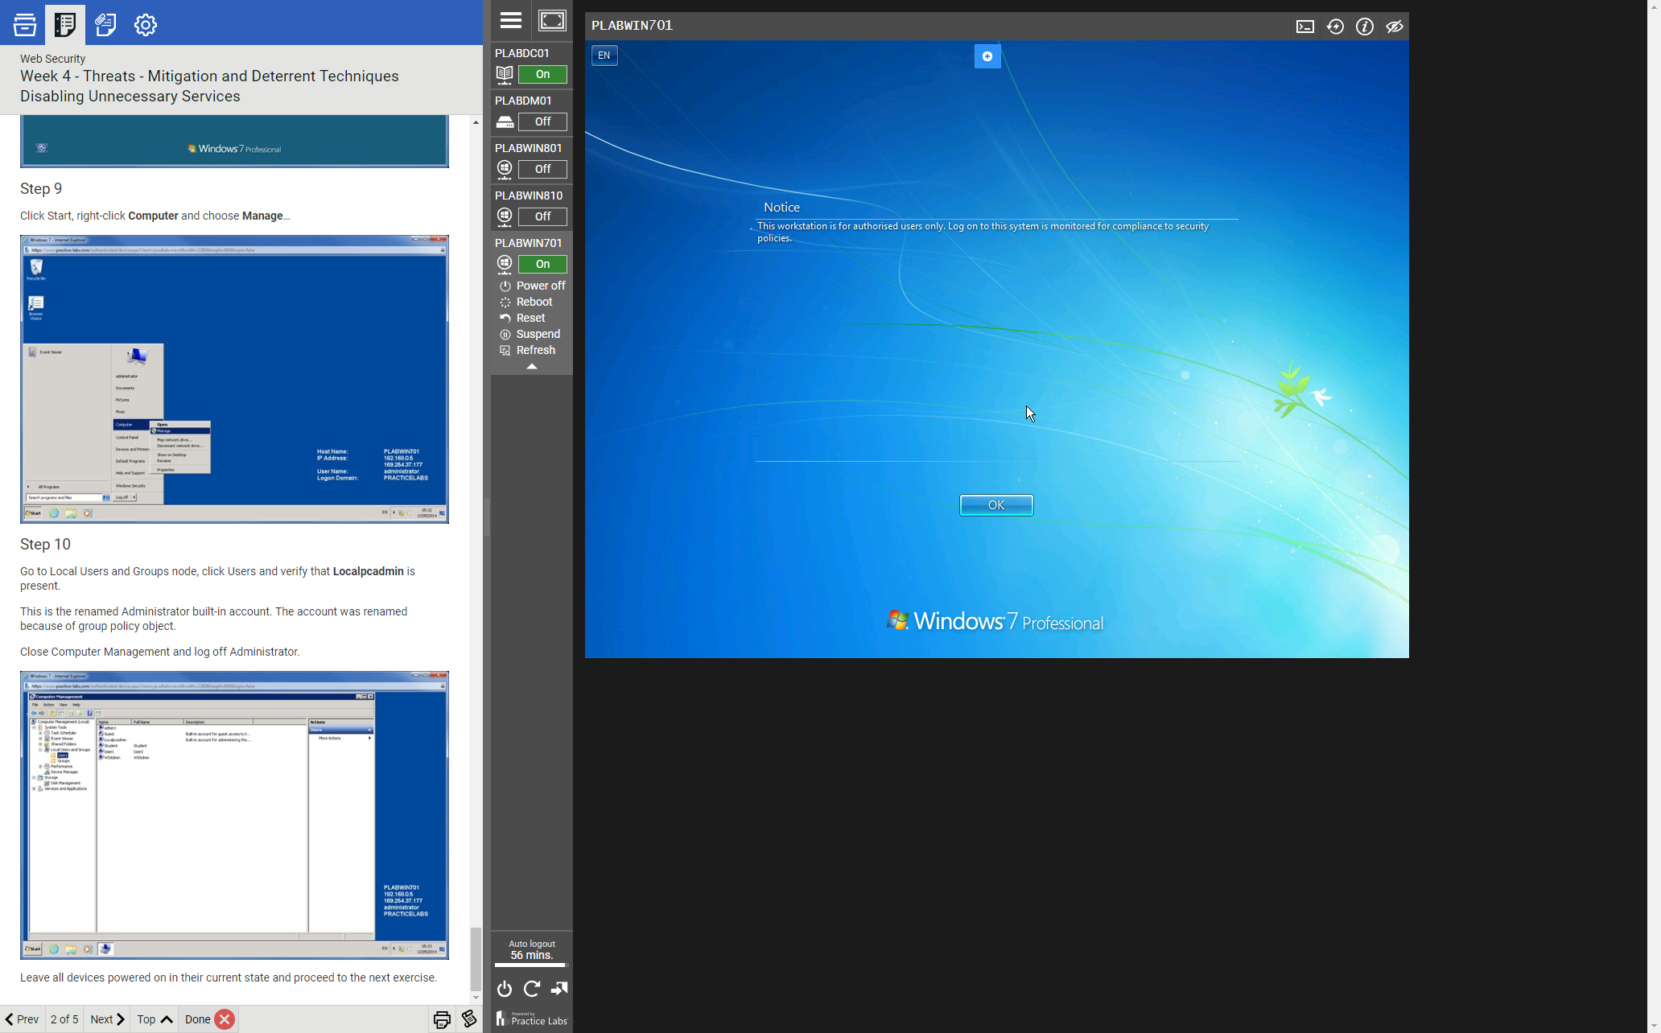

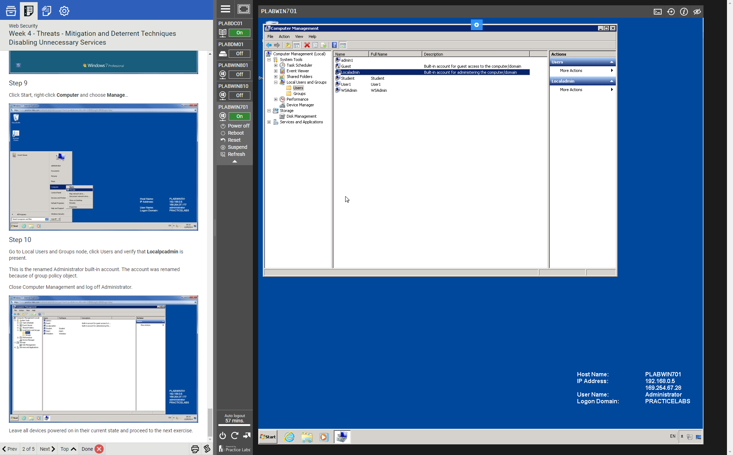

1. Take a screenshot of Exercise 2 Task 1 (disallow users to run some Windows applications)   
   Step 9. (10 points)

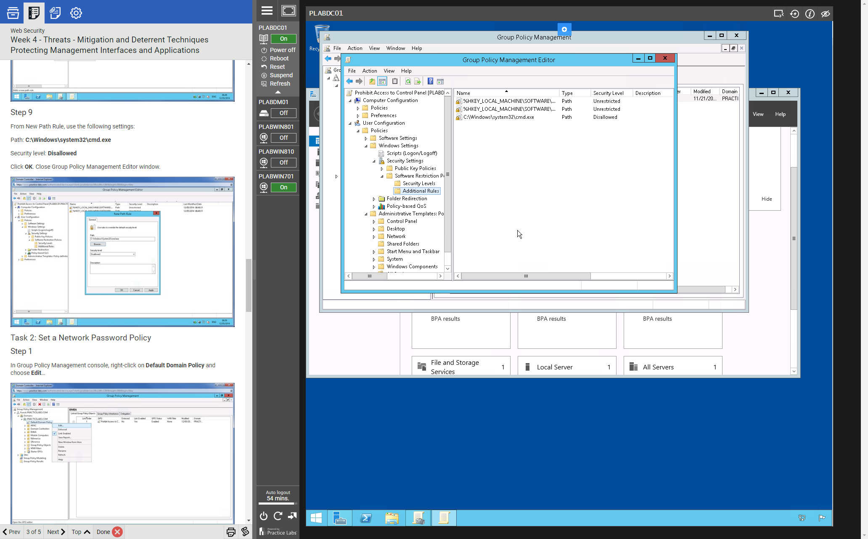

1. Take a screenshot of Exercise 2 Task 2 (set a network password policy)   
   Step 4. (5 points)

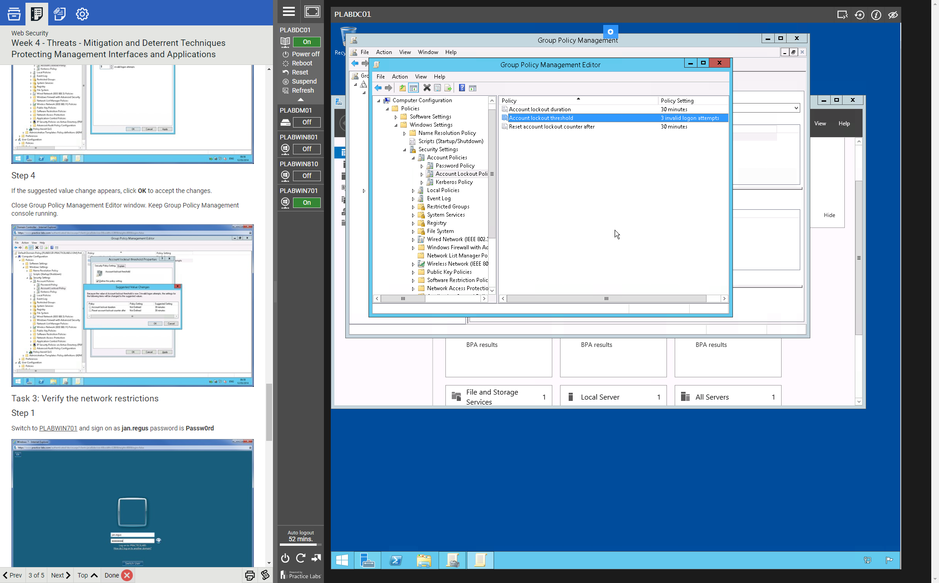

1. Take a screenshot of Exercise 2 Task 3 (verify the network restrictions)   
   Step 5. (5 points)

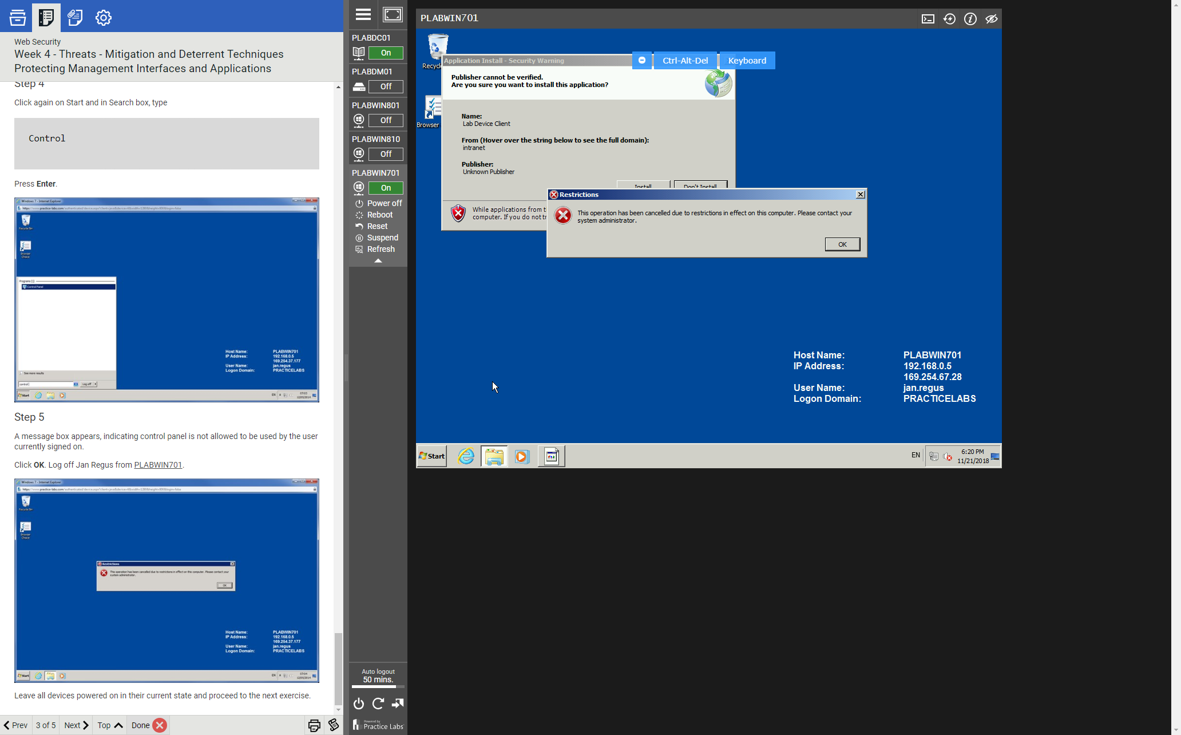

1. Take a screenshot of Exercise 3 Task 1 (renaming unnecessary accounts for security)   
   Step 7. (10 points)

